1. Set up a Selenium project in your preferred programming language (Java, Python, etc.).
2. Write code to open a web browser and navigate to the SpiceJet flight booking system (https://www.spicejet.com/).
3. Validate the Sign-Up Page by filling out Mandatory and Non-Mandatory Fields.
4. Write a code to Login with dummy email ID and Password on Popup fields after clicking Login button on top of the page.
5. Write code to search for flights by entering dummy origin and destination information for below types of trips:

One-way

Round Trip

1. Write code to select a flight and proceed to the booking page. 6
2. Write code to fill out the booking form with dummy passenger and payment information.
3. Write code to verify that the booking was successful by checking the resulting web page

for the booking confirmation message.

9. Write a code to validate below fields available on booking page

Check-in

Flight status

Manage Booking

10. Write code to close the web browser when testing is complete.

11. Write code to run the test suite automatically on a regular basis.

**Introduction**

The purpose of this project is to test some functionalities in the Spicejet website

Like Signup, login(positive & negative), RoundWaytrip, Onewaytrip, Uppermenu…

Here for design patter Page object modul is used and for frame Work I have used Cucumber Framework.

Cucumber Framework

Cucumber is a popular open-source testing tool used for behavior-driven development (BDD) of software applications. It allows for the creation of executable specifications written in plain text format, which can be easily understood by non-technical stakeholders such as business analysts and product owners. These specifications are typically written in a language called Gherkin, which uses a simple syntax to describe application behavior in terms of scenarios and steps.

In Cucumber, each scenario is defined in a feature file, which contains a series of steps that describe the expected behavior of the application. These steps are associated with corresponding code implementations, known as step definitions, which execute the actions described in the scenarios. By linking the plain text scenarios with executable code, Cucumber facilitates collaboration between technical and non-technical team members and helps ensure that the application behaves as expected.

Here i had create five feature file

1. login.feature

2. signup.feature

3. uppermenu.feature

4. onewaytrip.feature

5. Roundwaytrip.feature

login.feature

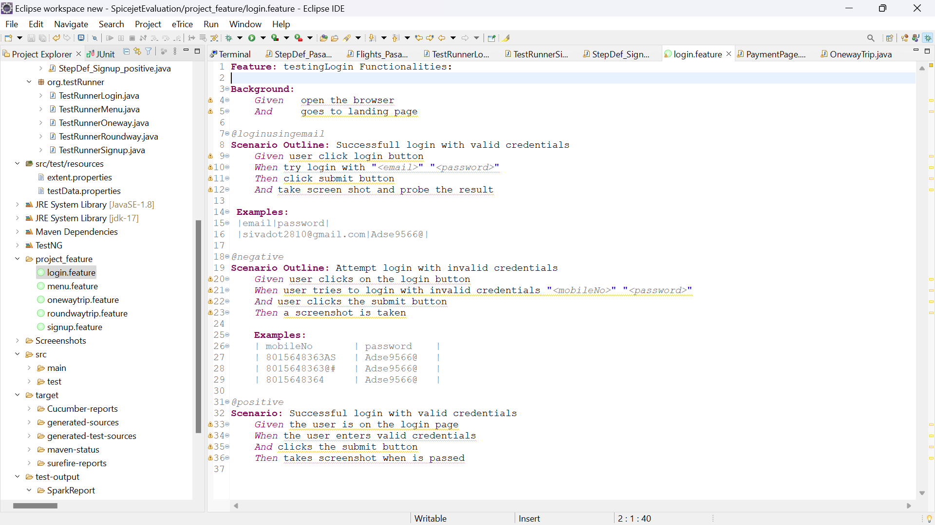

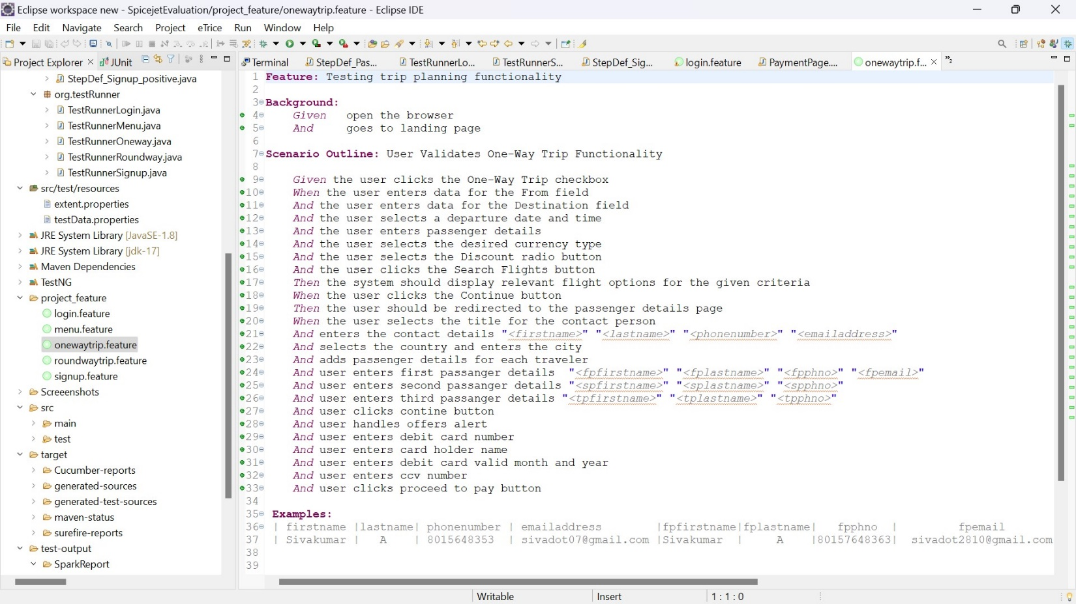Onewaytrip.feature

Stepdefinition

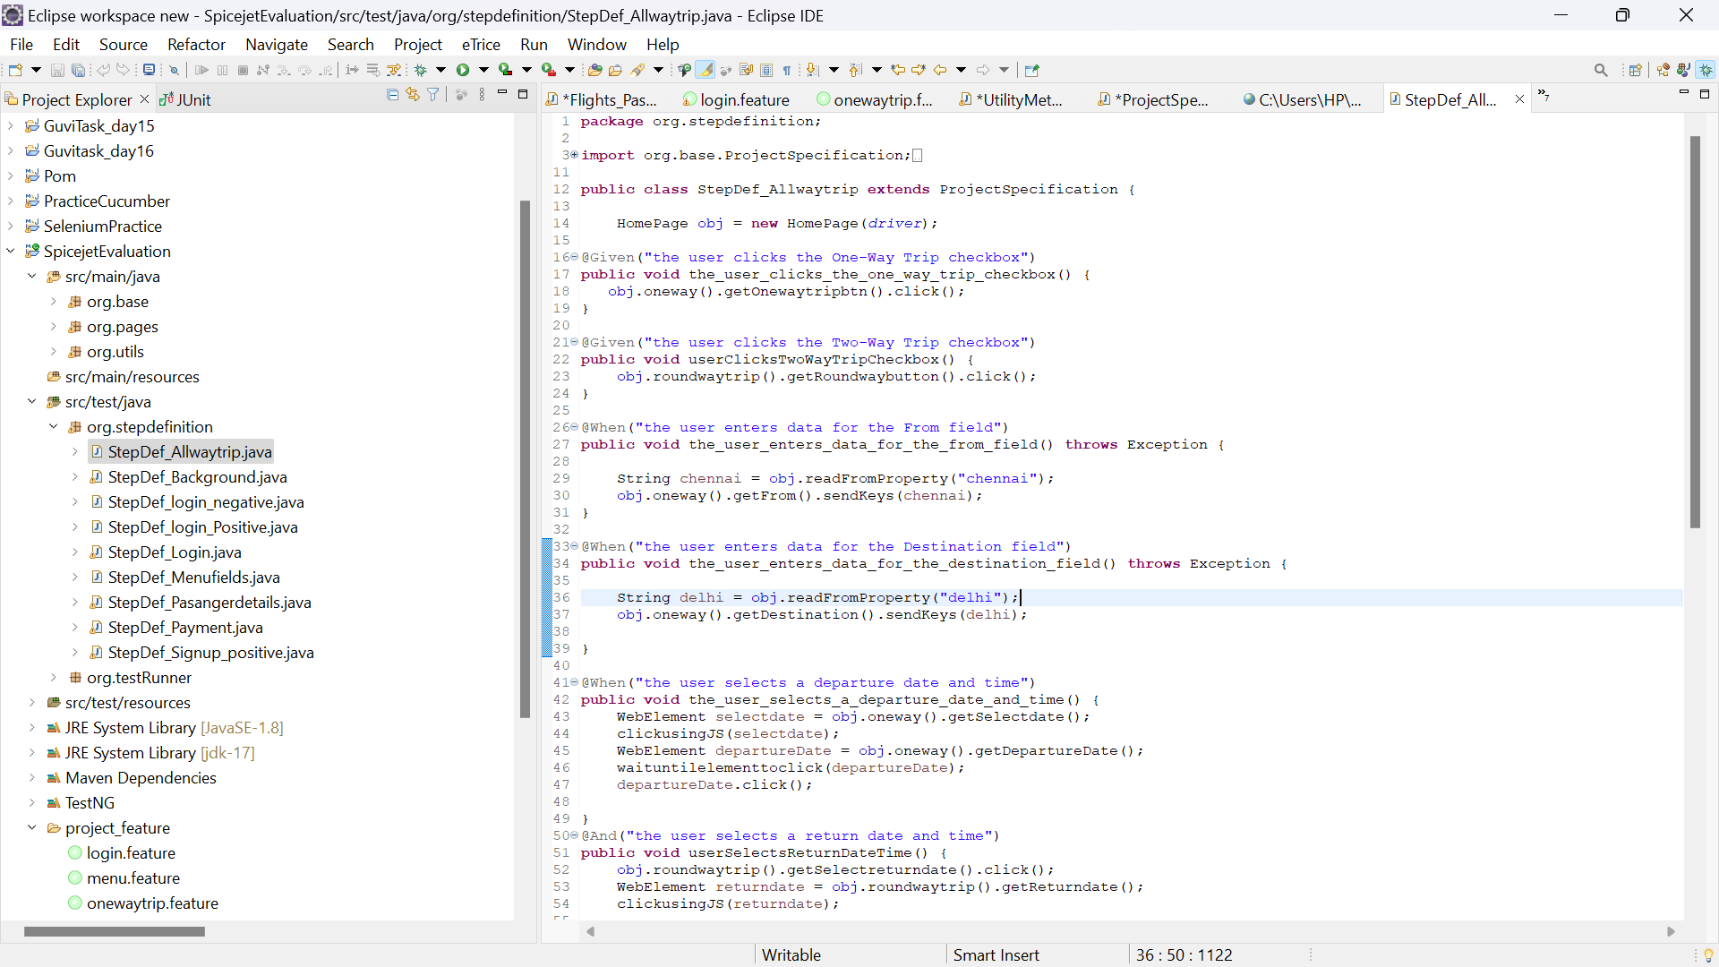The step definitions are the actual code blocks that execute the actions described by each step in the feature files. Each step in the feature file corresponds to a step definition in the codebase.

TestRunner calss

A test runner class is a component within a testing framework responsible for executing test cases and reporting the results

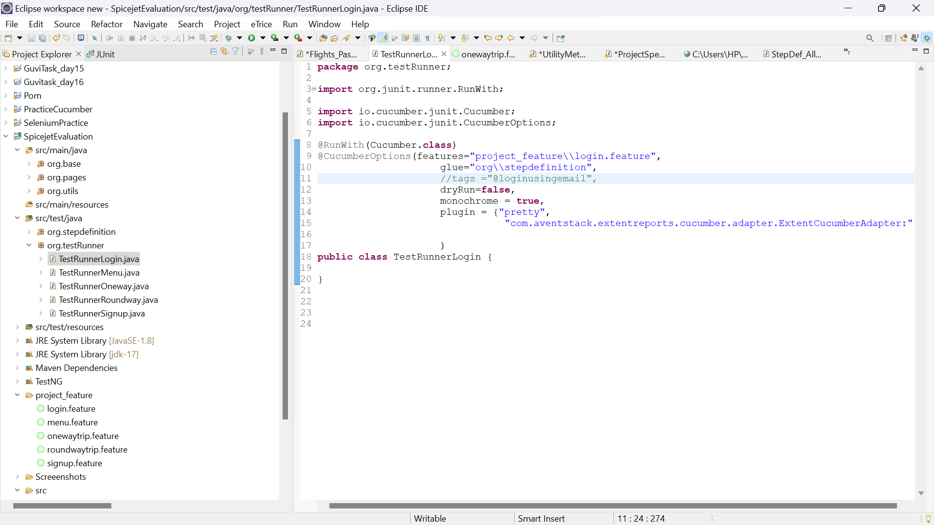

Page object model

Page Object Model, also known as POM, is a [design pattern in Selenium](https://www.browserstack.com/guide/design-patterns-in-selenium) that creates an object repository for storing all web elements. It helps reduce code duplication and improves test case maintenance.

In Page Object Model, consider each web page of an application as a class file. Each class file will contain only corresponding web page elements. Using these elements, testers can perform operations on the website under test.

* 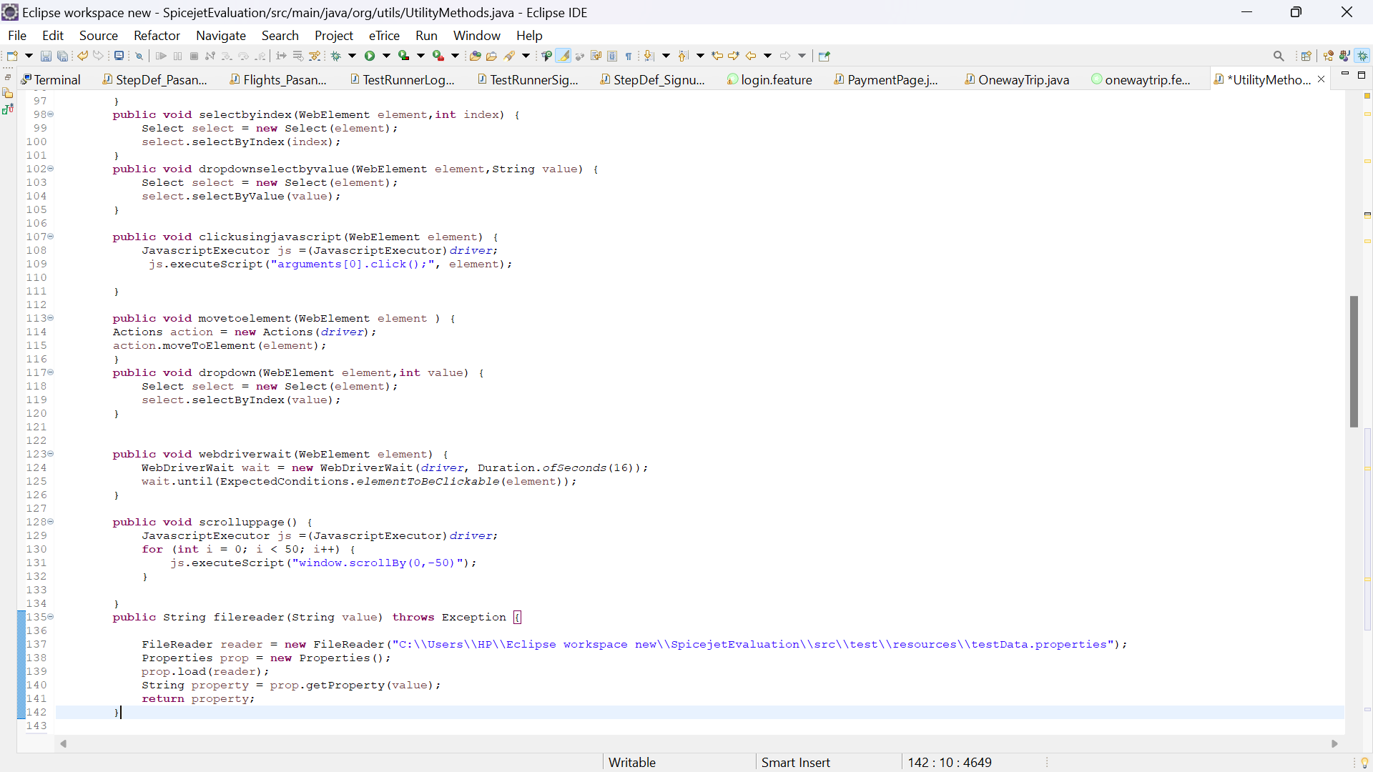Here I have used Page object model as design pattern, so I first I have created utility package and utility class here all the base methods will reside so when ever we want those method we can call that method from utility class
* Then I will crearte project specification class extends utility class so all the utility methods will reside project specification, here after the classes created all classes extends project specification class only so it appear clean and neat coding alaignment

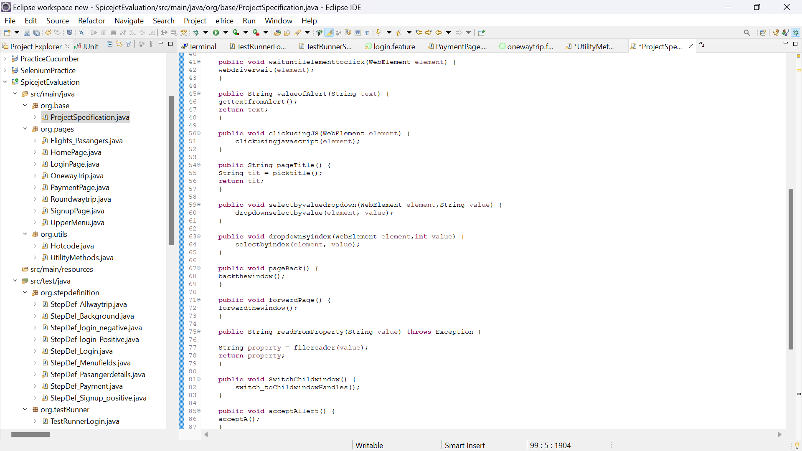

* And I stored all webelements in the page wice I created more than 6 pages bases on the Website behaviour

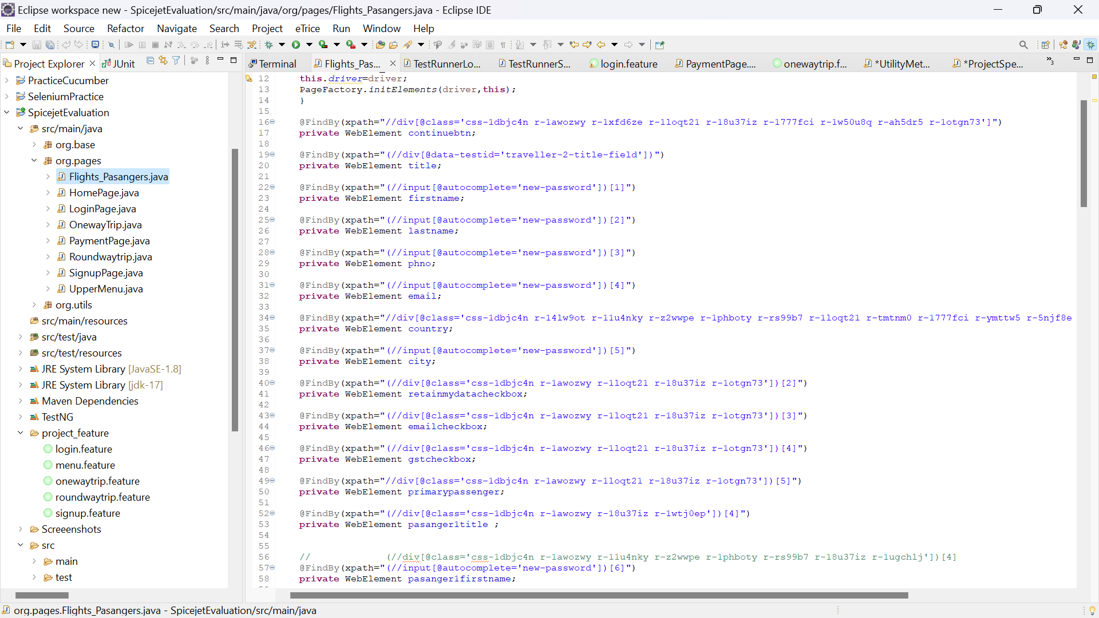Like Home page, Login page,signup page, payment page, oneway and round way trip pages

* 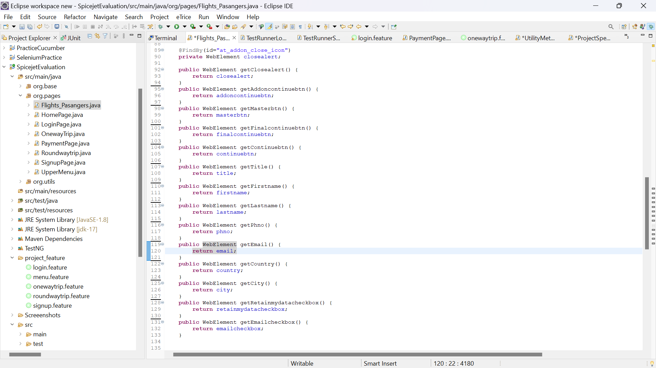And I used getters and setters to get the webelement from here and it will give binding code and methods so oops concept Encapualation will applied here

1. Write code to open a web browser and navigate to the SpiceJet flight booking system (<https://www.spicejet.com/>).

I creaed Cucumber background fo launching the browser and loading the url

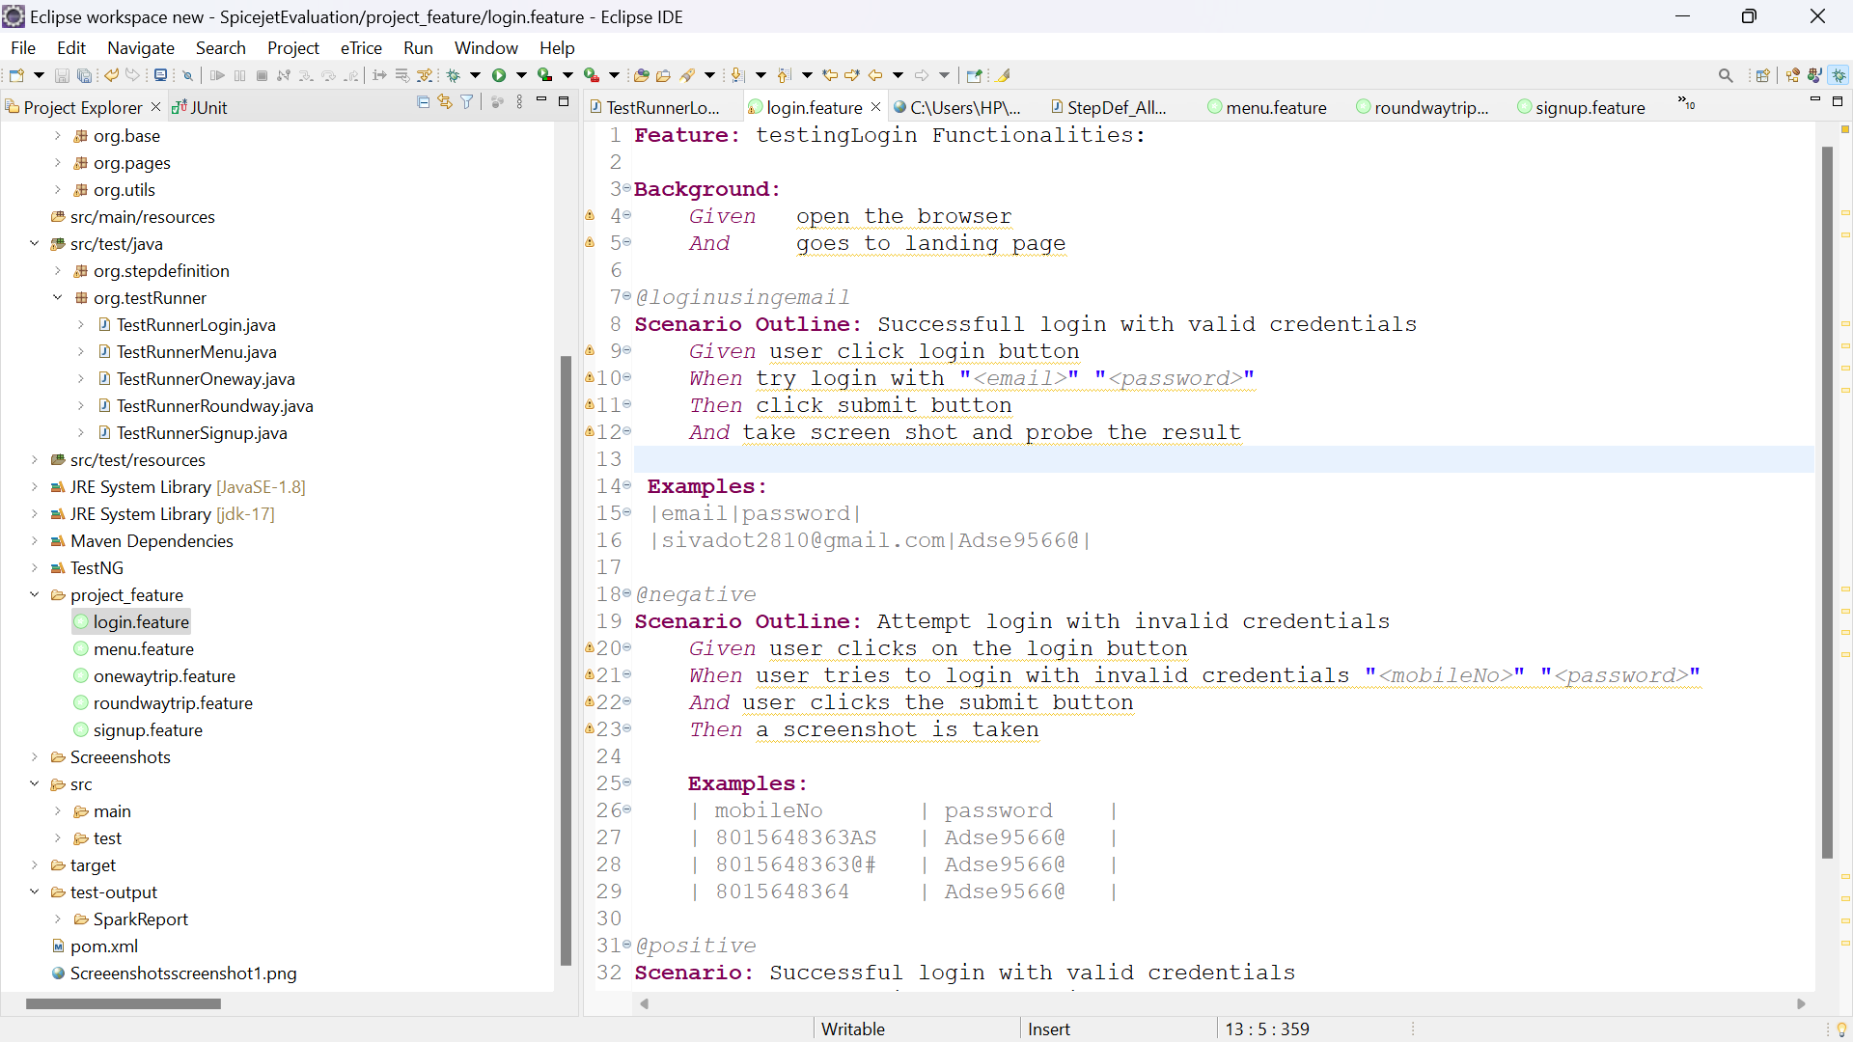

* And I have Wrote method for launching browser in Step definition class

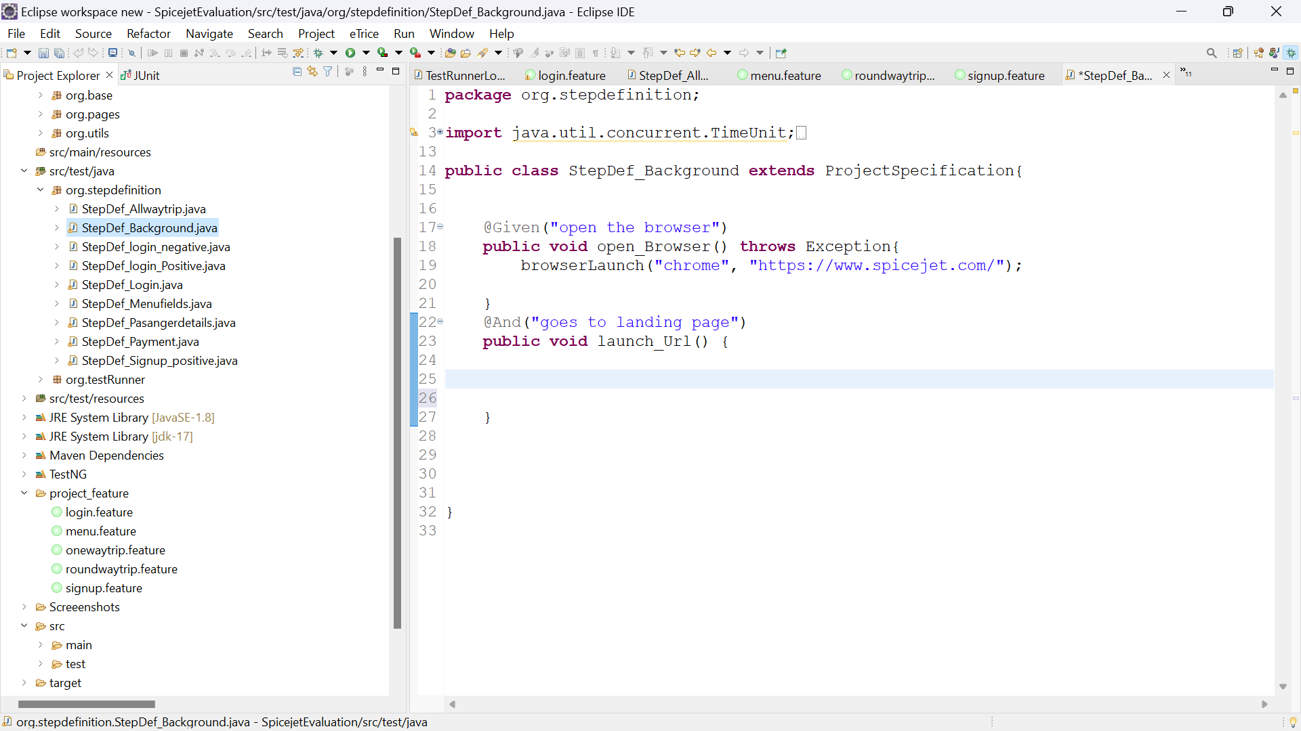

1. 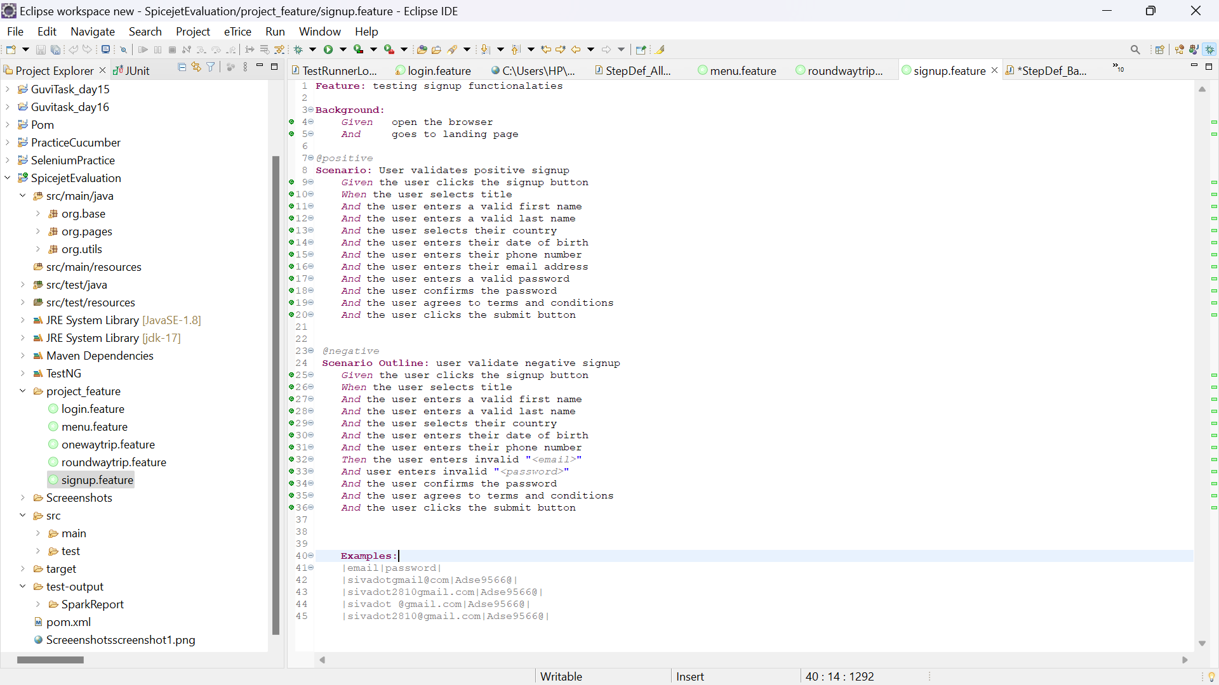Validate the Sign-Up Page by filling out Mandatory and Non-Mandatory Fields.

* 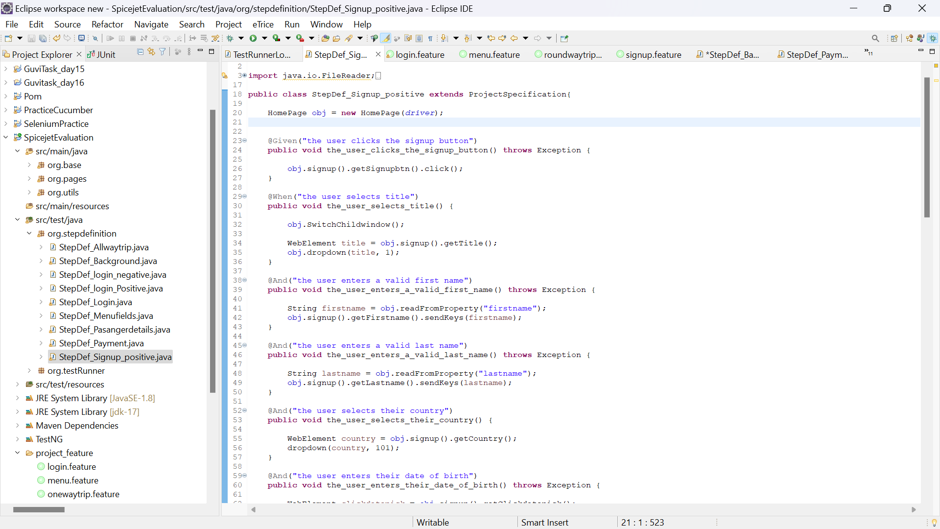I wrote the code to create signup automation in stepdefinition

1. Write a code to Login with dummy email ID and Password on Popup fields after clicking Login button on top of the page.

* 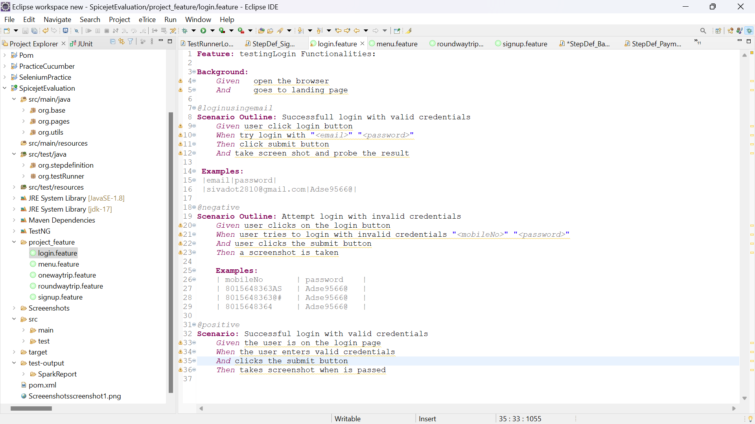I wrote the code for creating automation testing for login functionalities (here positive and negative loginTesting happened using Ccucmber Tags

Exe: @positive

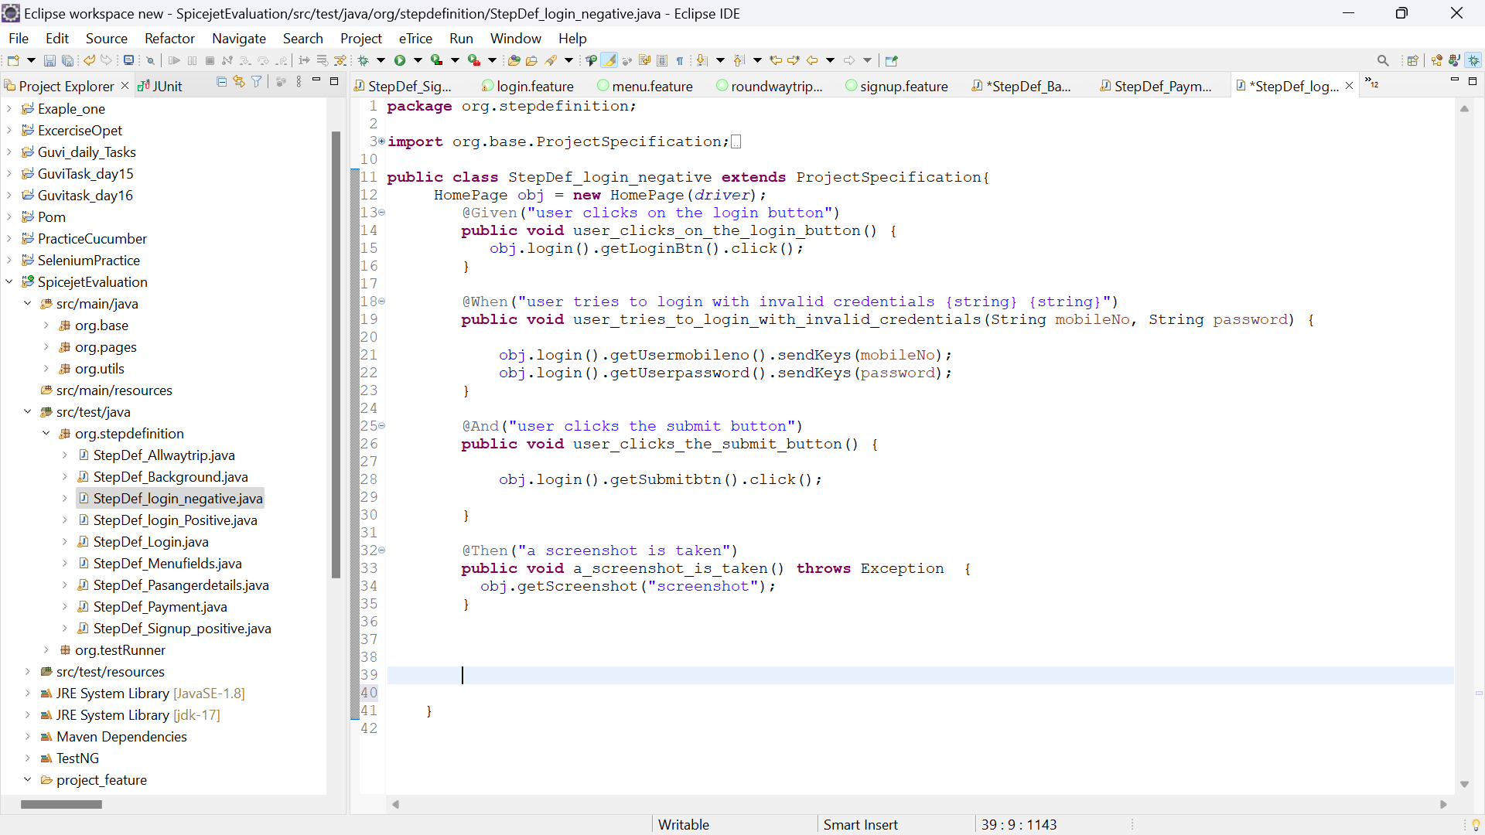@negative )

1. Write code to search for flights by entering dummy origin and destination information for below types of trips:

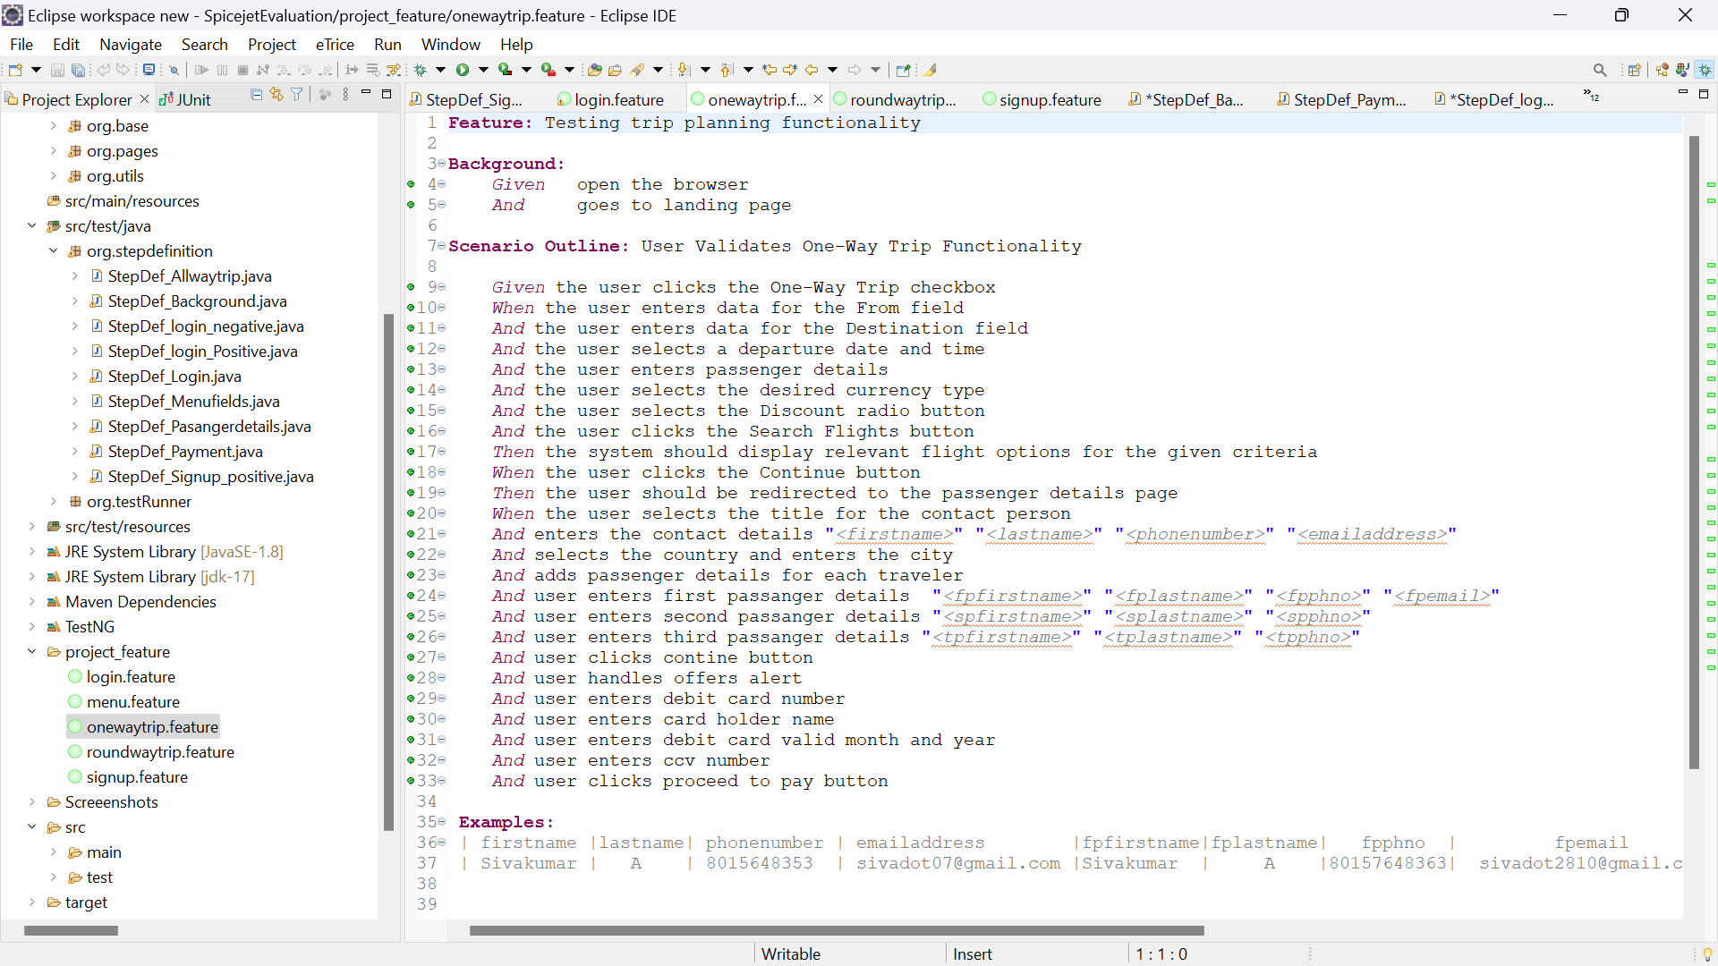One-way

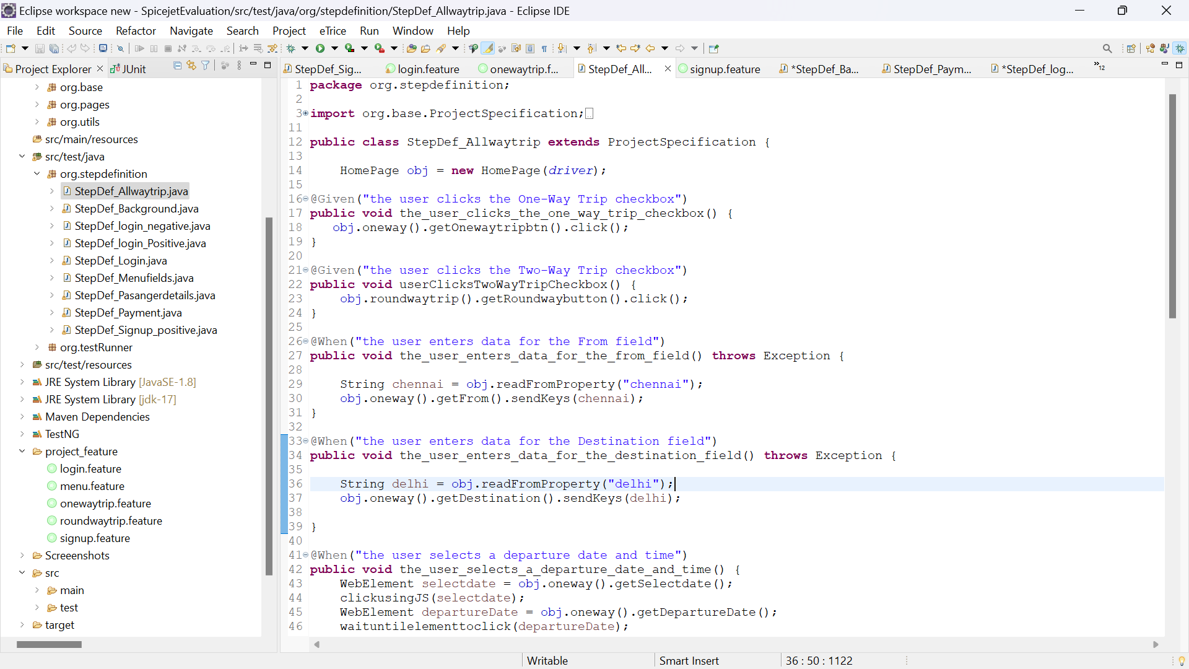Stepdefinition for One Way trip

6. Write code to search for flights by entering dummy origin and destination information for below types of trips:

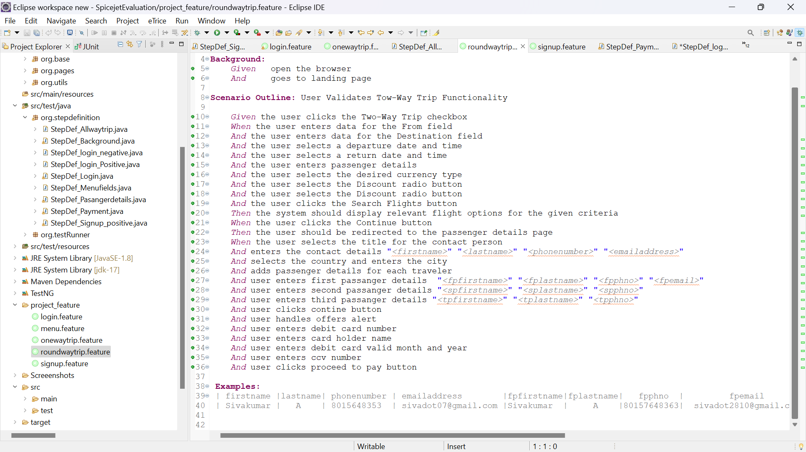Round Trip

Stepdefinition for round way Trip

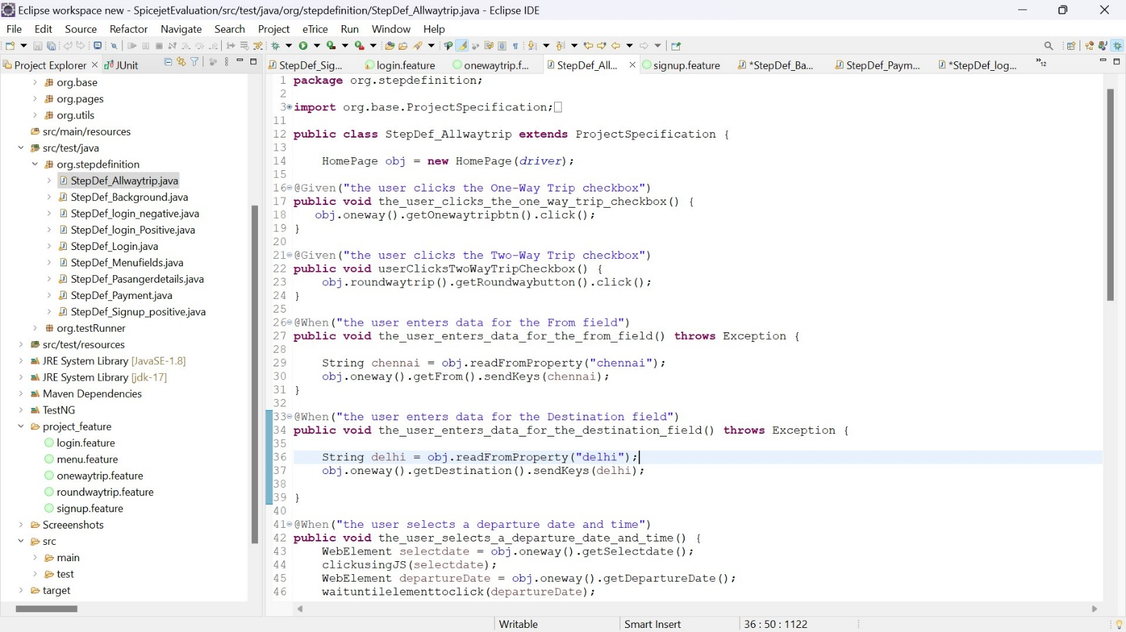

1. 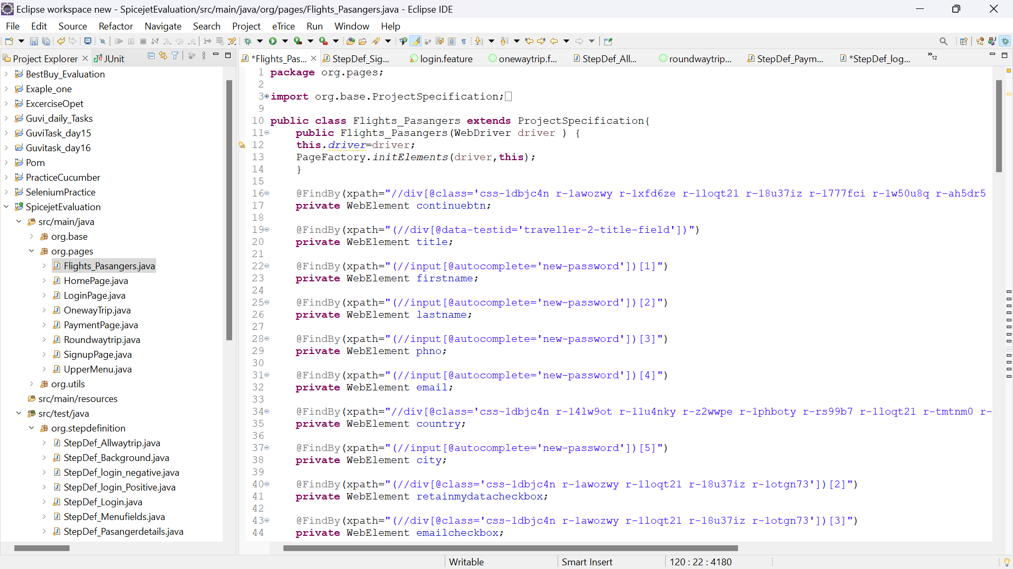Write code to select a flight and proceed to the booking page.

StepDefinition for Flight booking page and pasanger details page

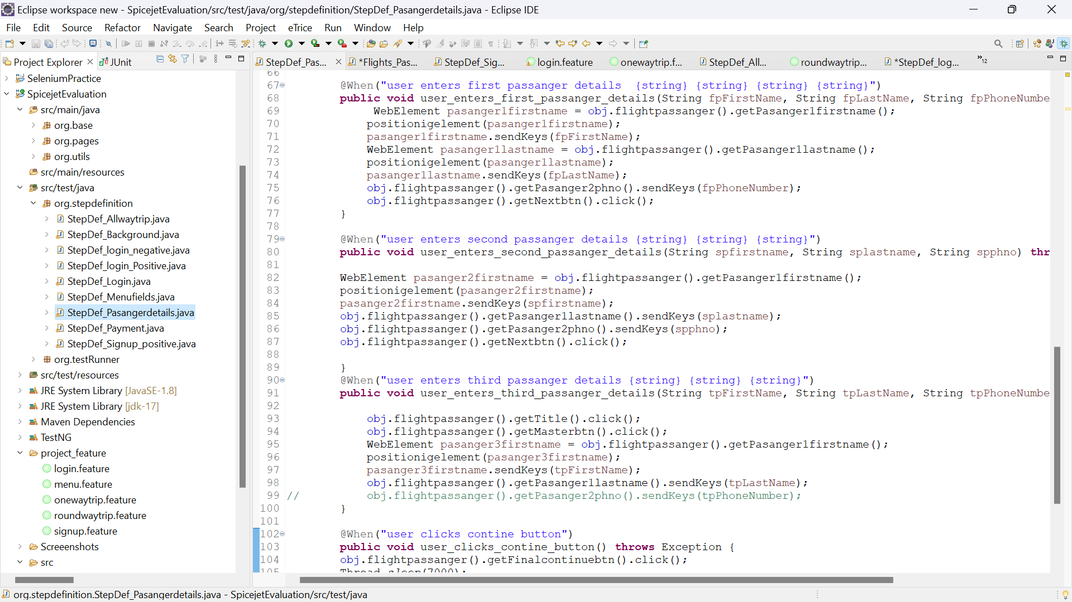

1. Write code to verify that the booking was successful by checking the resulting web page

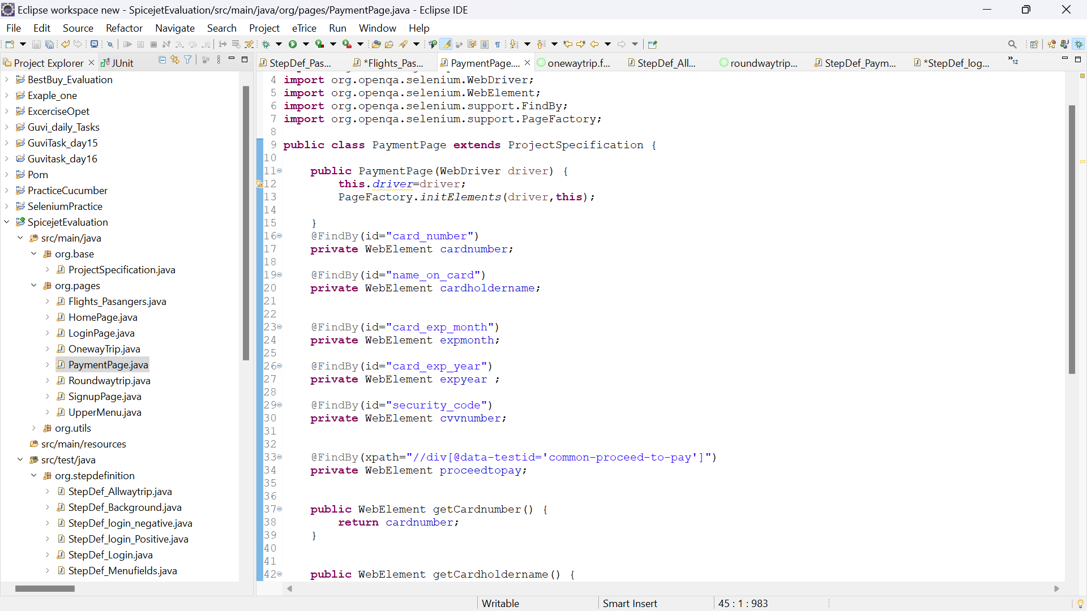for the booking confirmation message.

StepDefinition for Payment page

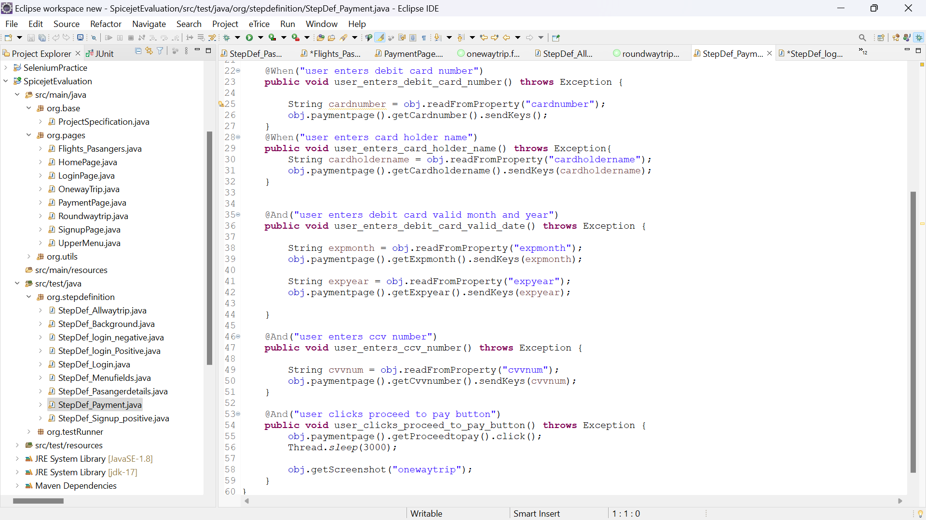

9. Write a code to validate below fields available on booking page

Check-in

Flight status

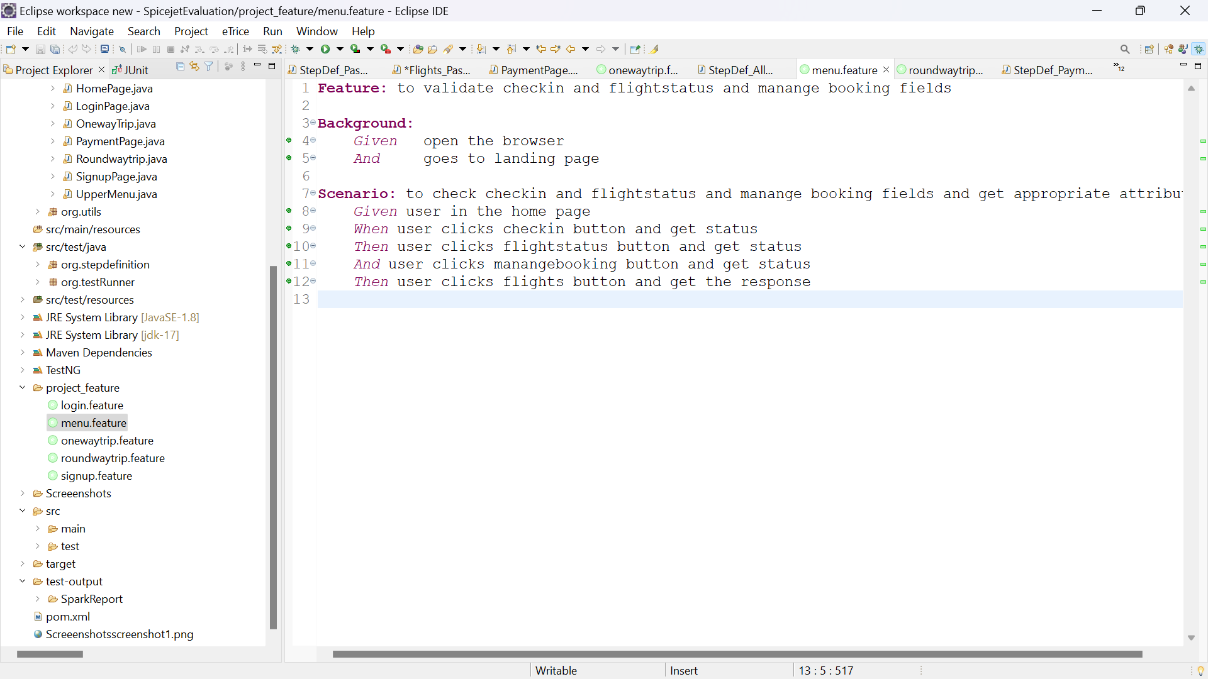Manage Booking

Stepdefiniton for menu options page

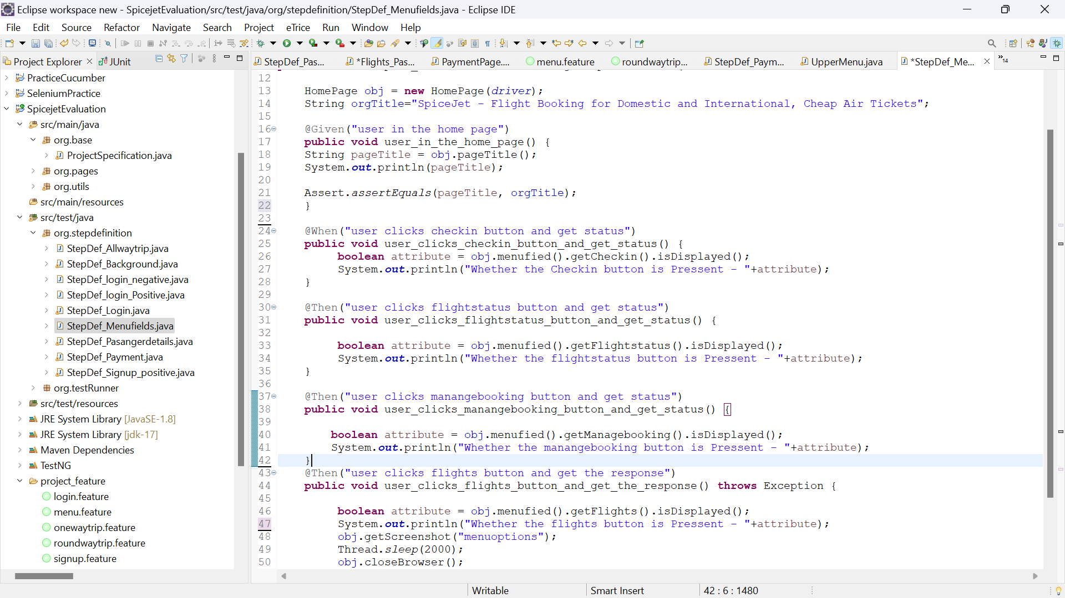

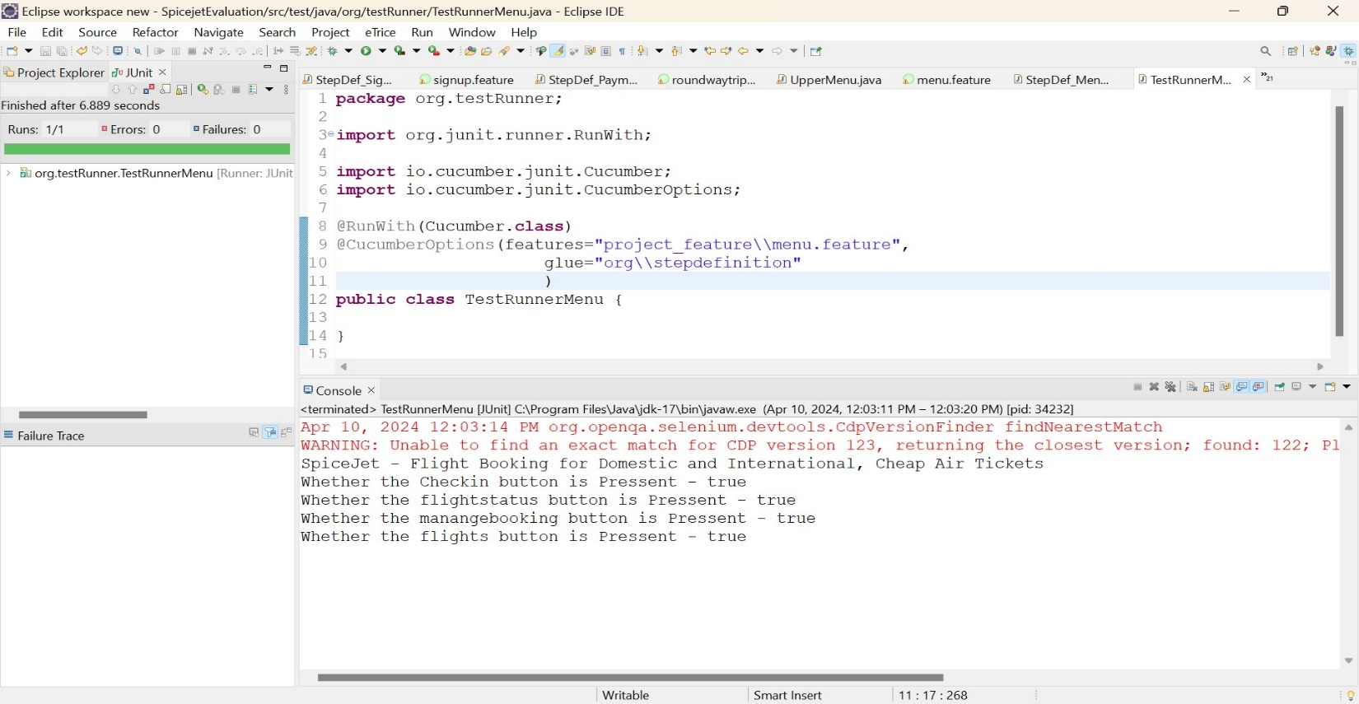Output:

10.Cucumber Extent report

Loginreport- <file:///C:/Users/HP/Eclipse%20workspace%20new/SpicejetEvaluation/test-output/SparkReport/login.html>

Menureport <file:///C:/Users/HP/Eclipse%20workspace%20new/SpicejetEvaluation/test-output/SparkReport/menu.html>

OneWaytrip : <file:///C:/Users/HP/Eclipse%20workspace%20new/SpicejetEvaluation/test-output/SparkReport/menu.html>

Roundway : [file:///C:/Users/HP/Eclipse%20workspace%20new/SpicejetEvaluation/test-output/SparkReport/Roundwaytrip.html](C://Users/HP/Eclipse%20workspace%20new/SpicejetEvaluation/test-output/SparkReport/Roundwaytrip.html%20)

Signupreport : [file:///C:/Users/HP/Eclipse%20workspace%20new/SpicejetEvaluation/test-output/SparkReport/signup.html](C://Users/HP/Eclipse%20workspace%20new/SpicejetEvaluation/test-output/SparkReport/signup.html)

Regression : <file:///C:/Users/HP/Eclipse%20workspace%20new/SpicejetEvaluation/test-output/SparkReport/regression.html>

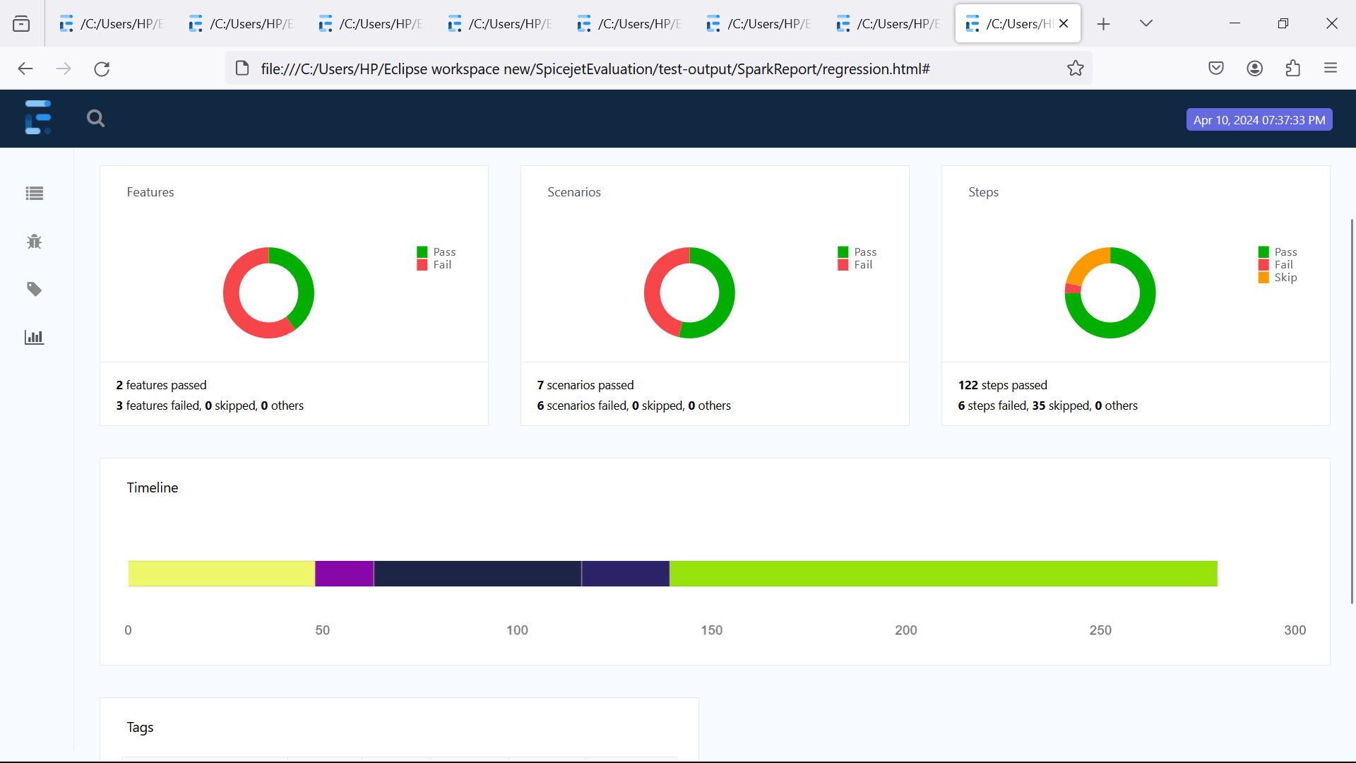Example report screenshot

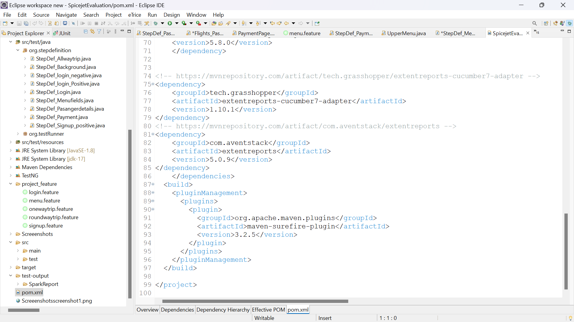11: Jenkins Intagration

